THE COGNITIVE INTERVIEW

INTRODUCTORY CLASS

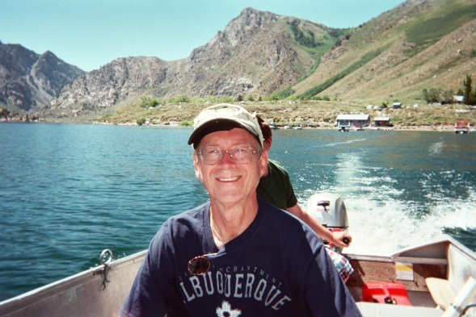

R. EDWARD GEISELMAN, PHD

UNIVERSITY OF CALIFORNIA, LOS ANGELES

CO-DEVELOPER OF THE COGNITIVE INTERVIEW PROTOCOL
FOR INVESTIGATIVE INTERVIEWING

UCLA PROFESSOR OF PSYCHOLOGY 40 YEARS
SERVING LAW ENFORCEMENT 40 YEARS

THE COGNITIVE INTERVIEW INTRODUCTORY CLASS
Information is the lifeblood of investigations and it is the ability of investigators to obtain useful and accurate information from eyewitnesses that is most crucial. Yet full and accurate memory recall is difficult to achieve. This proficiency course will familiarize investigators with the Cognitive Interview (CI) technique. The CI is a systematic approach to interviewing witnesses toward increasing the amount of relevant information obtained without compromising the rate of accuracy. The CI is based on scientifically derived principles of memory and communication theory as well as extensive analyses of law-enforcement interviews. The CI has been found in scientific studies to produce significantly more information than standard Q&A questioning. The CI is legally acceptable to the courts and is ideally suited for interviewing LEOs following use-of-force incidents.
Attendees will learn about the nature of memory retrieval and how to conduct investigative interviews more effectively while avoiding the worst mistakes. This class also includes a segment on techniques for detecting deception. Research shows that the reliability of red-flag indicators can be maximized through effective interview practices which comprise the CI for suspects (CIS).
Hosting this class is cost effective; trainers are left with everything needed to carry on the training of the CI/CIS once the class is over (PP slide shows, videos, handout materials).
GEISELMAN BIOGRAPHICAL SKETCH
R. Edward Geiselman is the co-developer of the Cognitive Interview technique. He has been a Professor of Psychology at the University of California, Los Angeles, for 34 years. He earned his undergraduate degree from Purdue University in 1972 where he studied engineering and psychology. Subsequently, he earned both Masters and PhD degrees from Ohio University in experimental psychology. Since joining the faculty at UCLA, he has published over 100 research papers in social-science and police-science journals. He is the author of five books including The Psychology of Murder, Intersections of Psychology, Psychiatry, and Law (Volumes 1, 2, & 3), Eyewitness Expert Testimony, and Memory Enhancing Techniques for Investigative Interviewing: The Cognitive Interview. Professor Geiselman has conducted training and offered other consulting services for numerous investigative agencies including the FBI, Homeland Security, US Secret Service, US State Department, US Marshals Service, Los Angeles Police Department, Los Angeles Sheriff’s Department, Singapore Police Force, Health and Human Services, NTSB, Los Angeles Metropolitan Transit Authority, U.S. Marine Corps, Walter-Reed Army Hospital, Black Hat, Force Science Institute, and Hong Kong’s Independent Commission Against Corruption. He also conducts investigative interviews for local police departments in ongoing cold-case investigations. Dr. Geiselman was awarded the Mary-Ellen McCormick award by the LASD in 2013 for his career contributions to the investigation of child abuse cases.

R. Edward Geiselman, PhD
Professor Emeritus, UCLA

Contact via Email: geiselma@psych.ucla.edu
COGNITIVE INTERVIEW SEMINAR OUTLINE

- INTRODUCTION

- OVERVIEW OF MEMORY RETRIEVAL

- OVERVIEW OF THE COGNITIVE INTERVIEW

- SEQUENCE OF THE COGNITIVE INTERVIEW

- Introduction
- Narrative
- Probing Memory Scenes (specific questions)
- Review
- Closing the Interview

- ROLE PLAY EXERCISES

- COMMUNICATION TECHNIQUES

- SPECIAL CONSIDERATIONS AFTER FORCE

- SPECIAL POPULATIONS OF WITNESSES

9. COGNITIVE INTERVIEW (CI) SUMMARY

10. COGNITIVE INTERVIEW FOR SUSPECTS (CIS)

BASIC COGNITIVE INTERVIEW TEMPLATE

Rapport
- Ask “who they are and what do they do.”
- Explain who you are.

Interview Instructions
- Explain transfer of control (they have the information, you were not there).
- Explain this will require considerable effort on their part.

Narrative
- Recreate context leading up to even under investigation.
- Ask to be complete, report everything.
- Ask to take their time, go slowly, close eyes if want, and to concentrate.
- Do not interrupt.
- Take limited notes about images to probe, rank images on which might have most information (to be probed first).

Specific Questions Phase
- Use their words to focus on richest image.
- Use open ended question first (“tell me more about”).
- Do not interrupt, use pauses effectively.
- Stick with one image before moving on to another.
- Go through each image on your list.
- Now conduct reverse-order recall.
- Now conduct change perspectives recall.

Review
- Ask them to interrupt you if they want to change anything.
- Use their words to re-tell event from beginning to end.
- Stop periodically to see if they want to add anything.

Closure
- Thank them for their efforts.
- Offer contact information.

SUMMARY COGNITIVE INTERVIEW FOR SUSPECTS

1 - Rapport/Introduction – Develop dependency. “Friends tell friends secrets.”

2 - Narrative – Promote “verbal vomit.” More rope to hang a liar; liars want to be evasive.

3 - Drawing/Sketch – Monitor for inconsistencies (unanticipated request). Liars have difficulty drawing out their fabricated story, and they do not anticipate this request.

4 - Follow-up, open-ended questions – Monitor for elaboration and indicators. Liars say little that is new, and they exhibit behavioral leakage.

5 - Reverse Order – Monitor for inconsistencies and indicators. Liars have difficulty complying with this request, they do not anticipate this request, and they exhibit behavioral leakage.

6 - Confrontation – Firm denial? Liars object and deflect an answer. Monitor for elaboration, liars add little that is new. [Use “drip” method for information disclosure – this adds pressure and does not allow for a coherent explanation from a liar.]

7 - Review – Generate a key change and monitor reaction. Liars will let the apparent error by the interviewer go uncorrected.

8 - Closure – Explain consequences of not coming forward at this time. It’s worth a shot.

